**Intrusion Detection System (IDS)**

**Explanation of Implementation: -**

**Login Page: -**

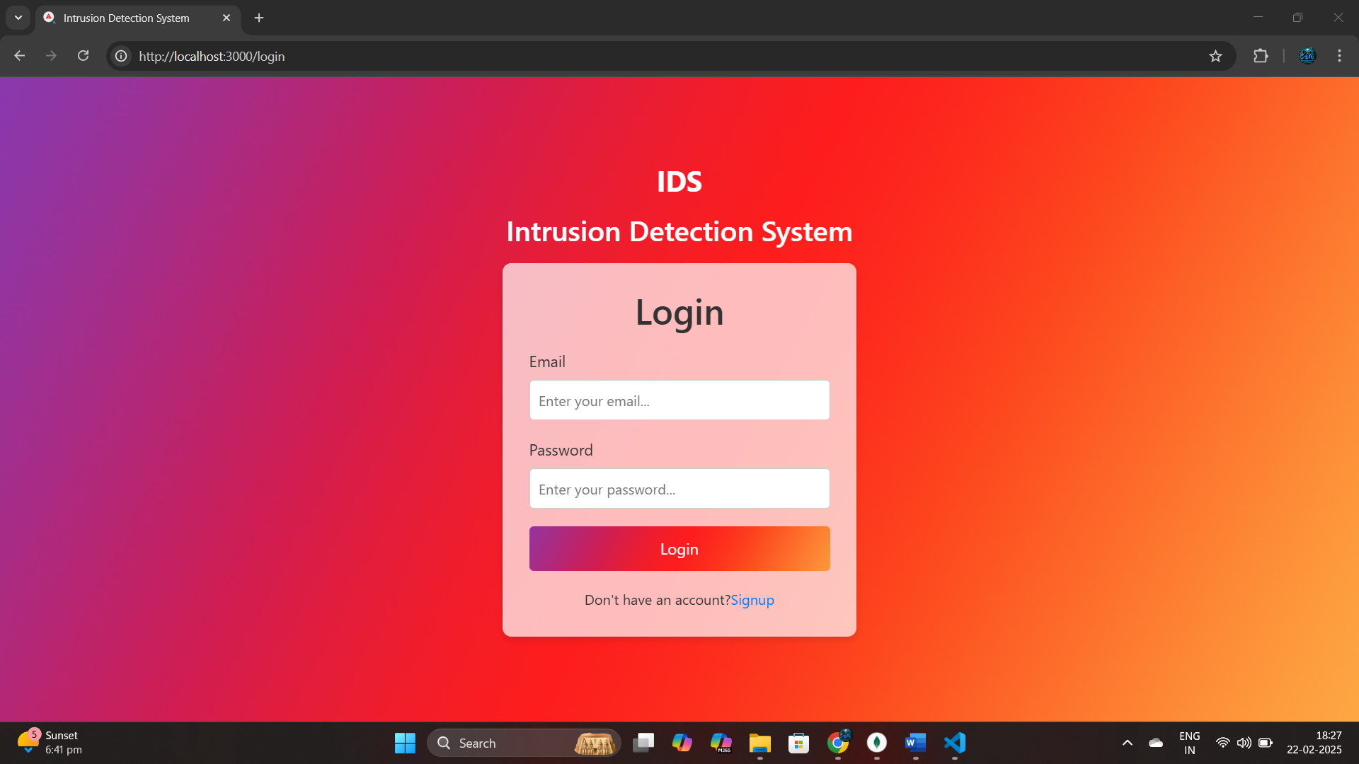

**Registration Page:-**

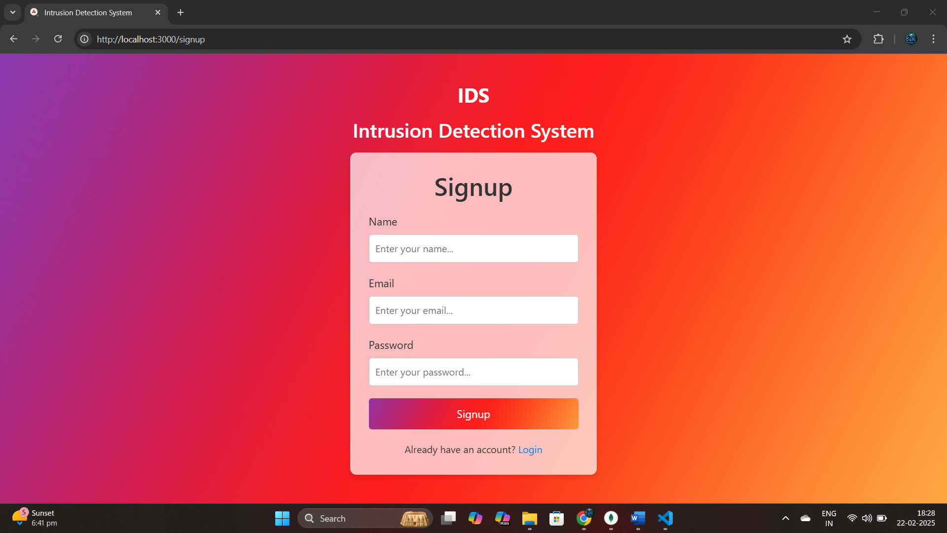

**As soon as someone registers it gets stored in the Database for future login:-**

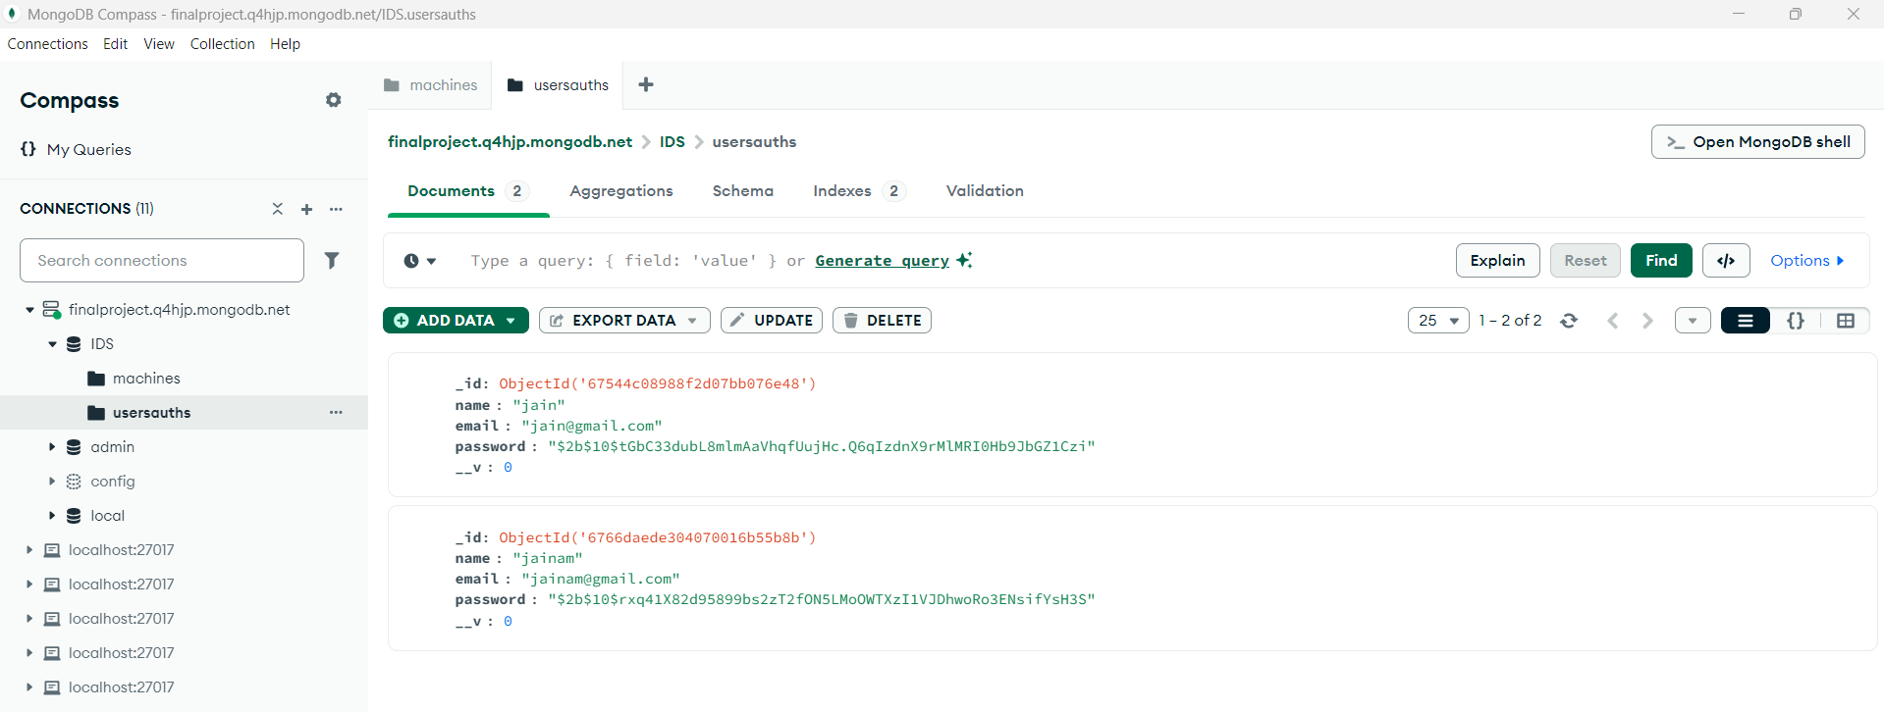

**The main Page where user can view their stored information of machines:-**

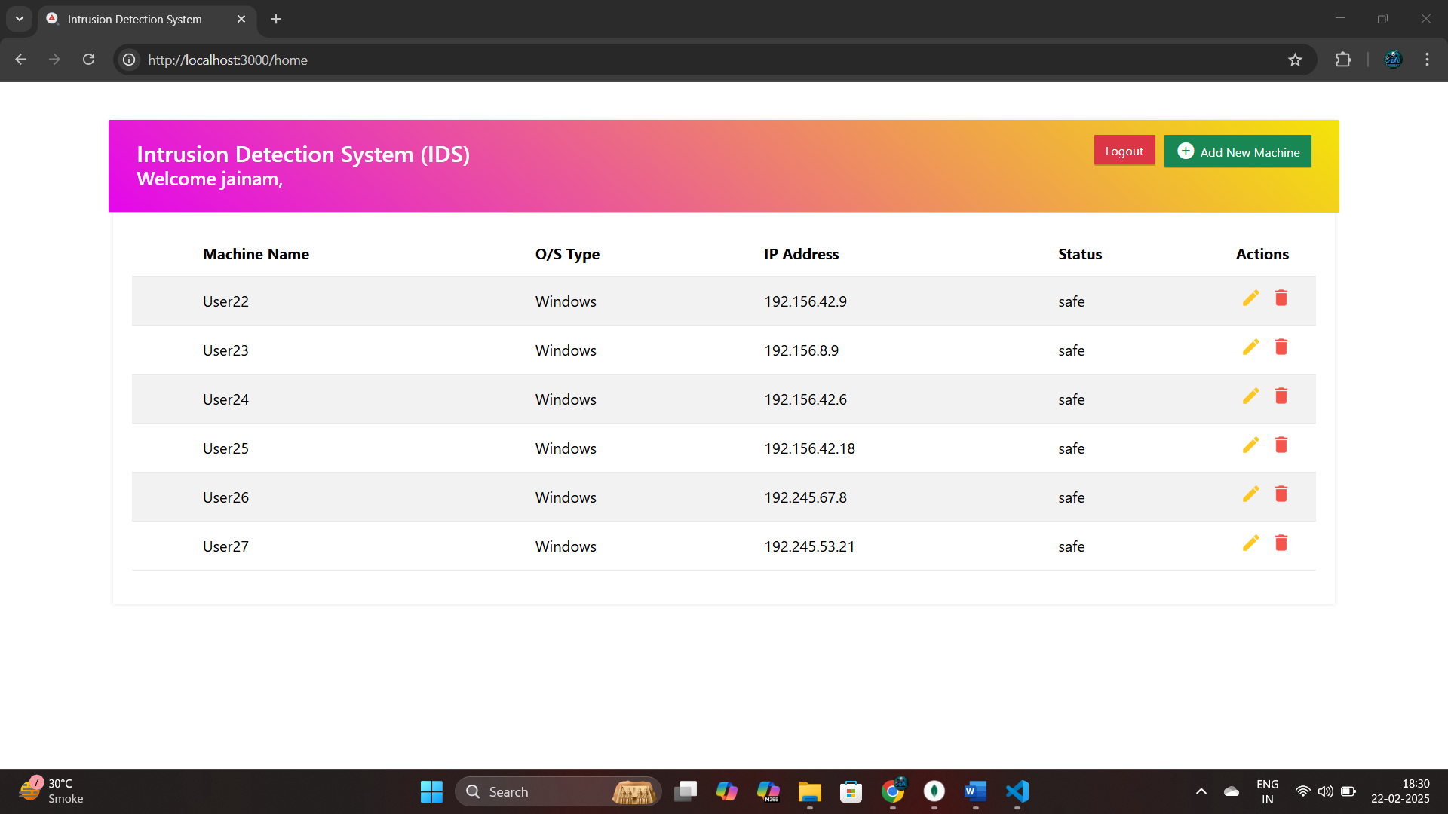

**The Add Machine Form to help the user to add new machine:-**

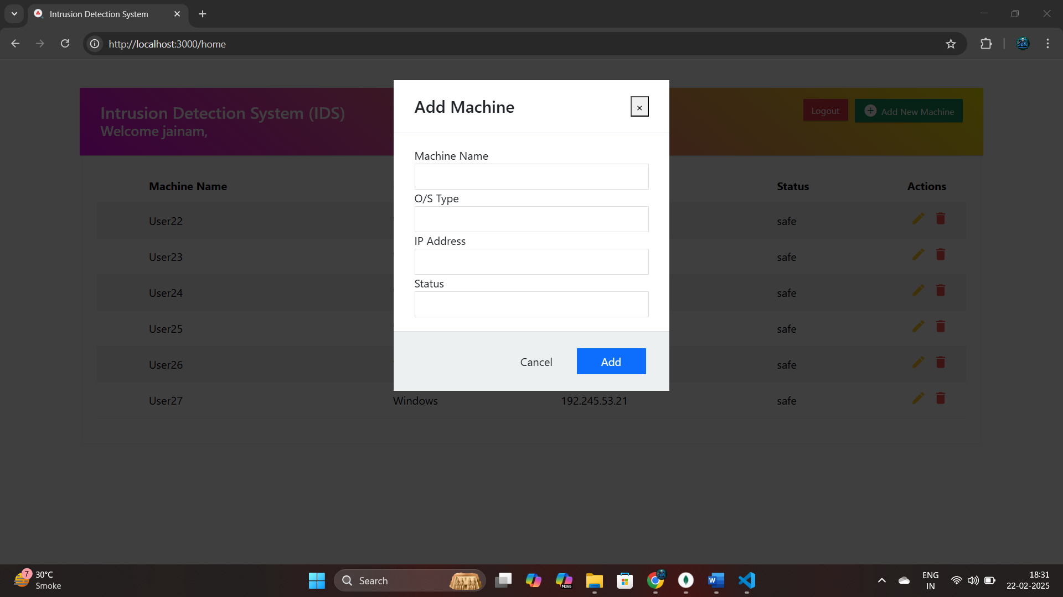

**The Update Machine Form to help the user update their previously stored machine:-**

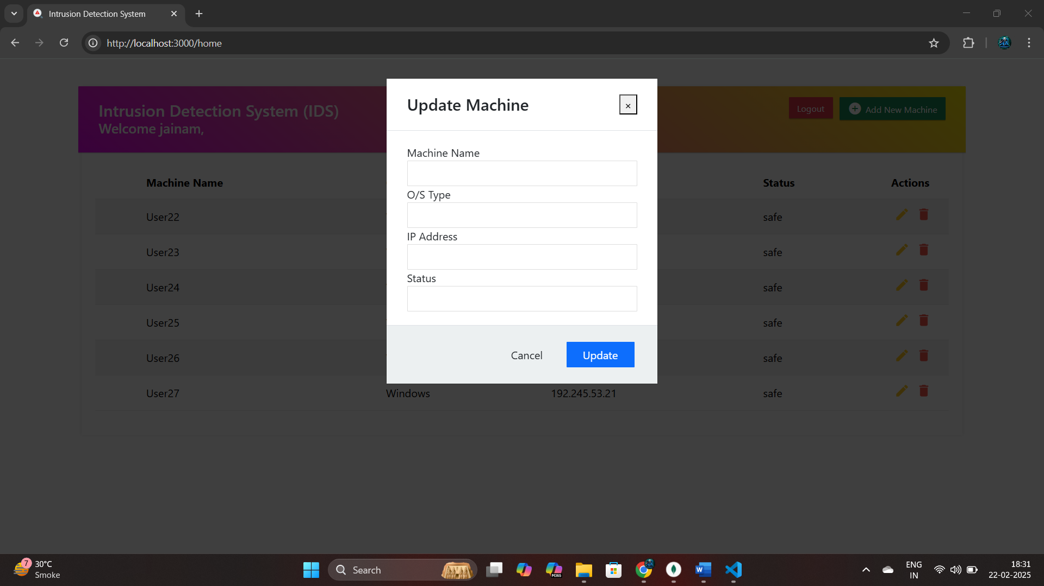

**The Delete Machine icon to help the user to delete the machine:-**

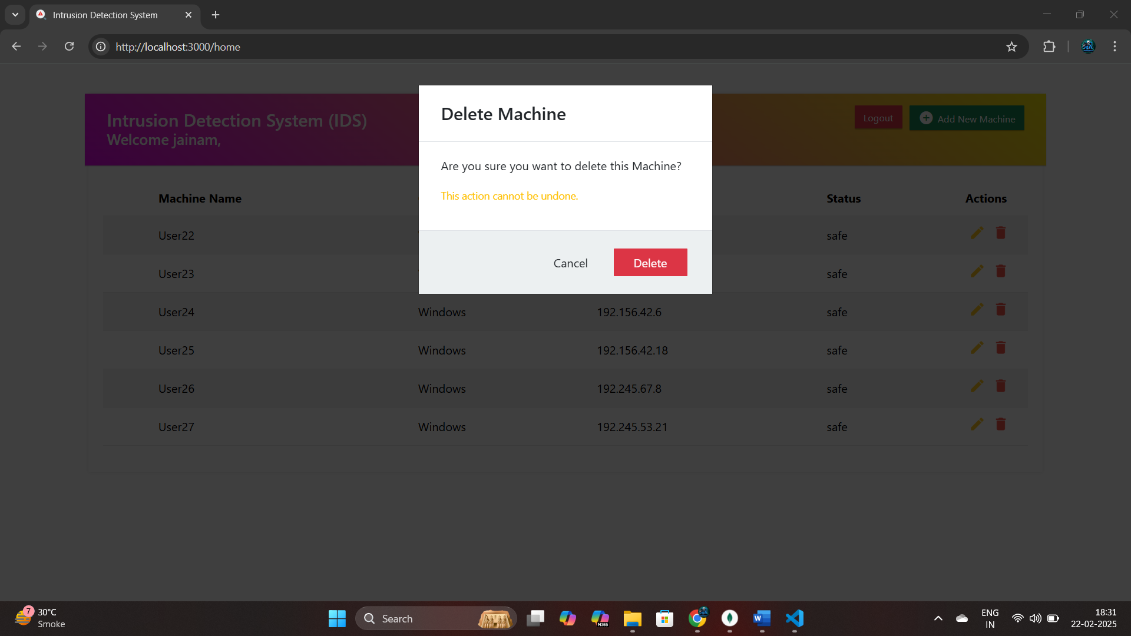

**As soon as you add the machine info it also gets add to the database:-**

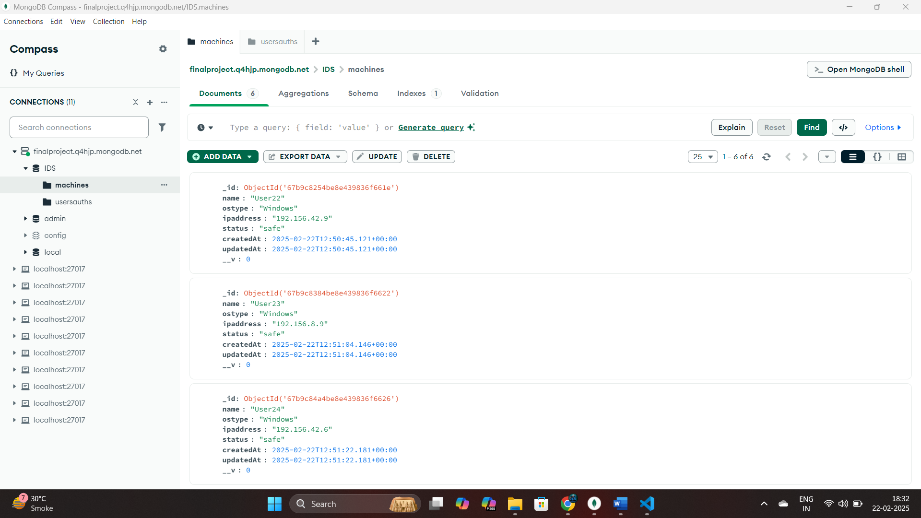

**You Can add the machine Details Manually or the script “IPScanner.py” adds the machine Information which are connected in LAN using the CAT Cable by scanning the Network Continuously: -**

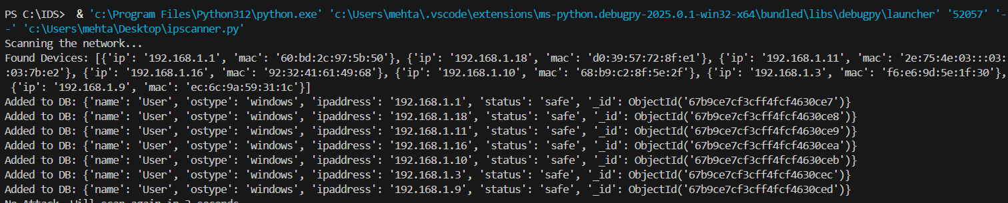

**Here in the above output, You can See that the Ip Addresses of the devices which are connected are scanned and added To the Database.**

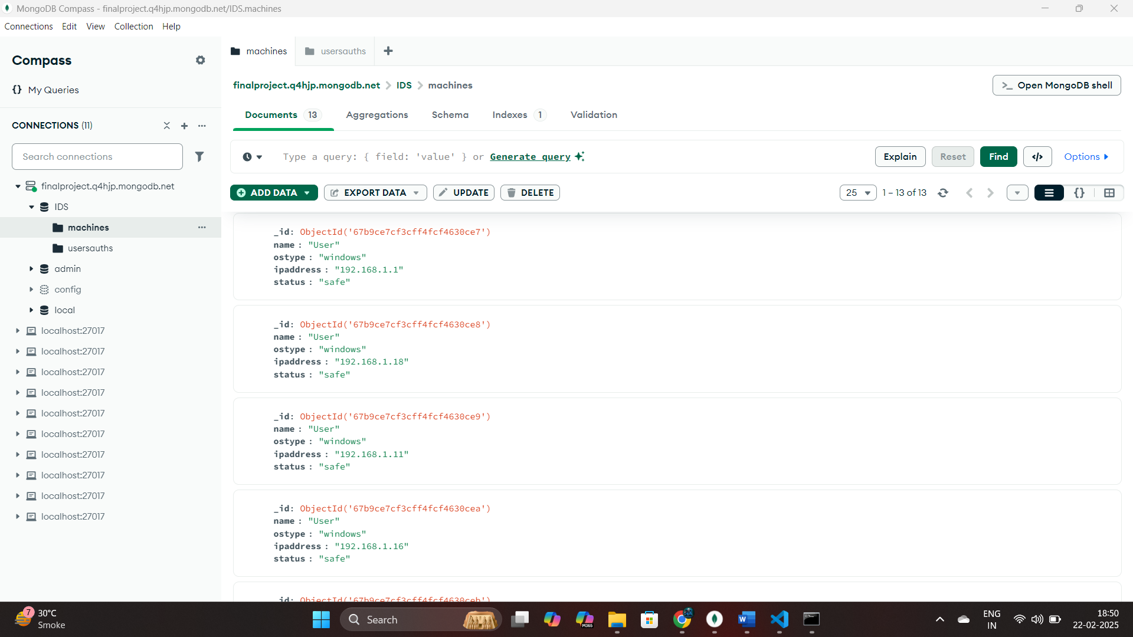

**The Devices which are scanned are also now automatically visible in the Web Monitoring UI:-**

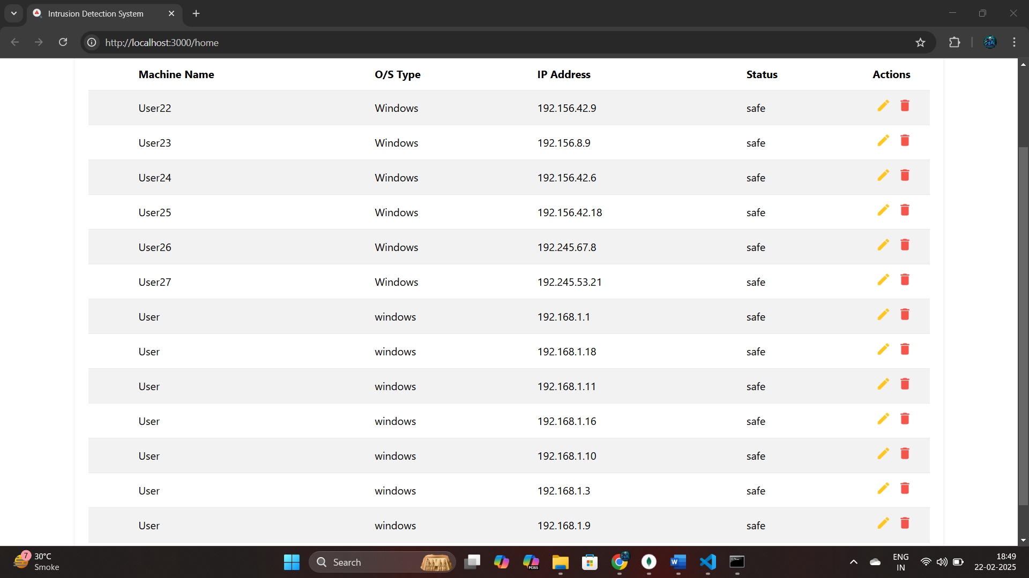

**Now will see the Attack intensity predictor which takes various parameters of DOS Attack and predicts intensity or severity of threat:-**

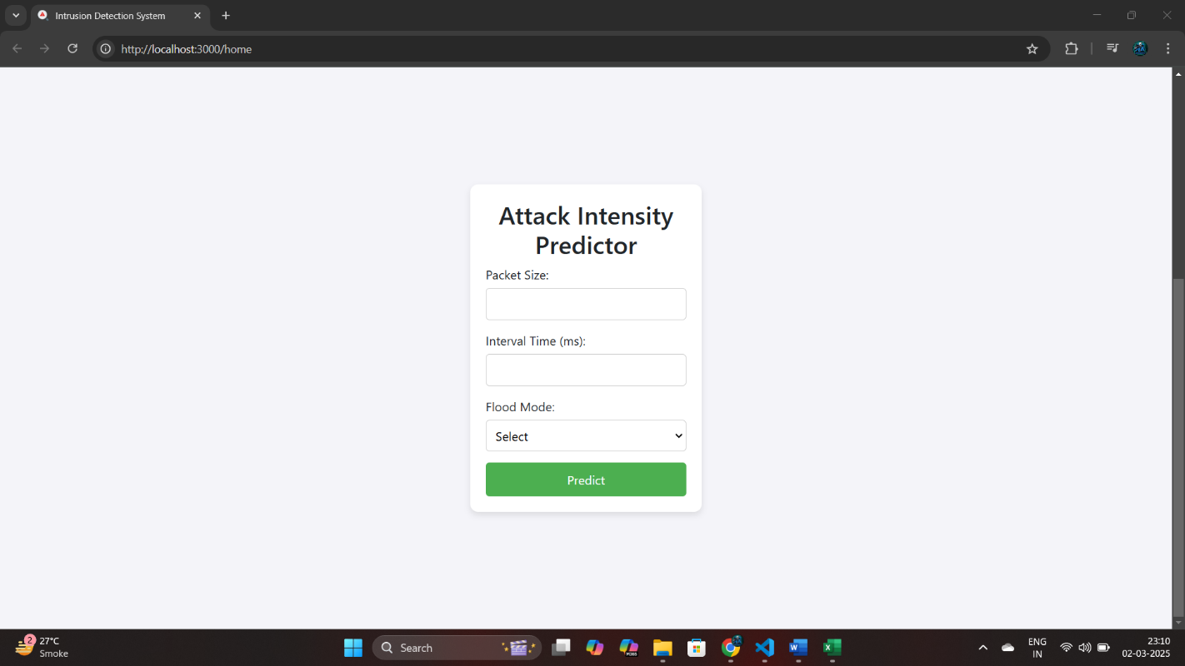

**In the below picture you can see it will predict the intensity of attack which can be normal medium and strong.**

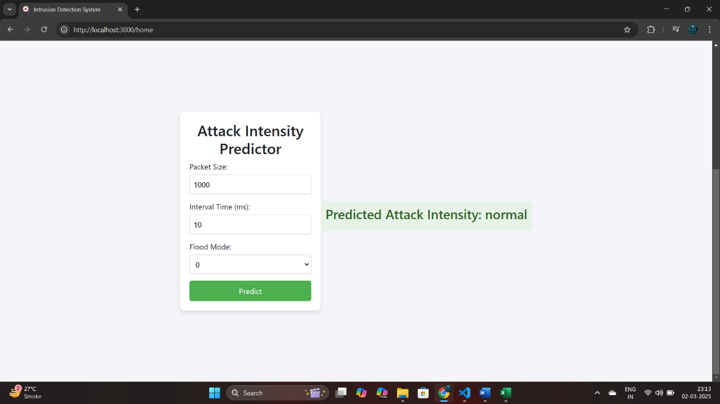

**Now let see the working of Intrusion Detection System:-**

**The below is the windows (victim machine) with ip Address 192.168.1.2**



**It is added in the web monitoring UI where status is safe:-**

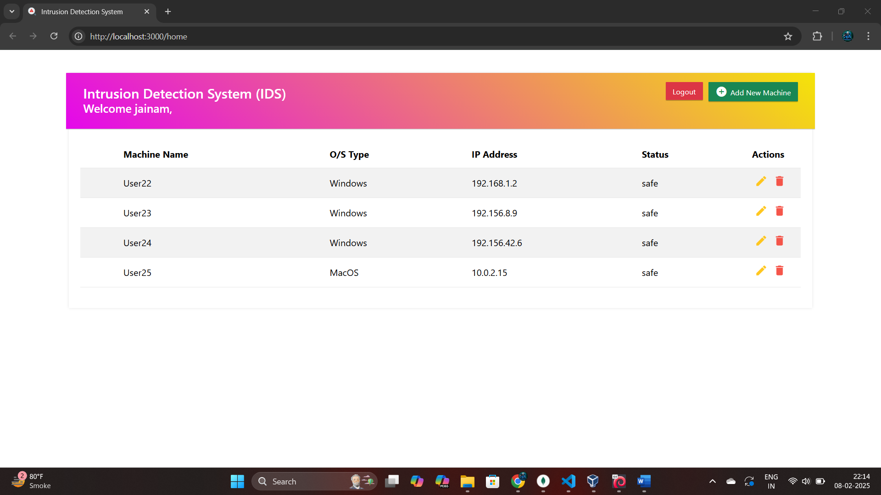

**As well as in the database:-**

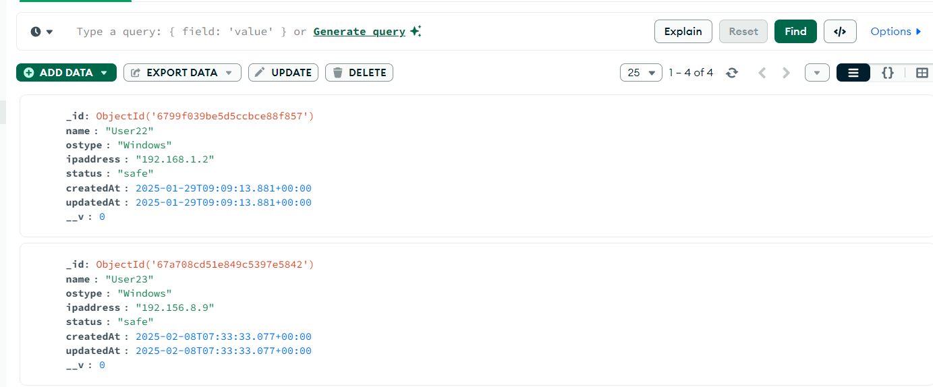

**The given below is the kali linux machine with IP 192.168.1.50 to launch the attack:-**



**Now we will start the “IntelligentAgent.py” script in victim machine which continuously scans for attack by Analyzing the packets received over the network:-**

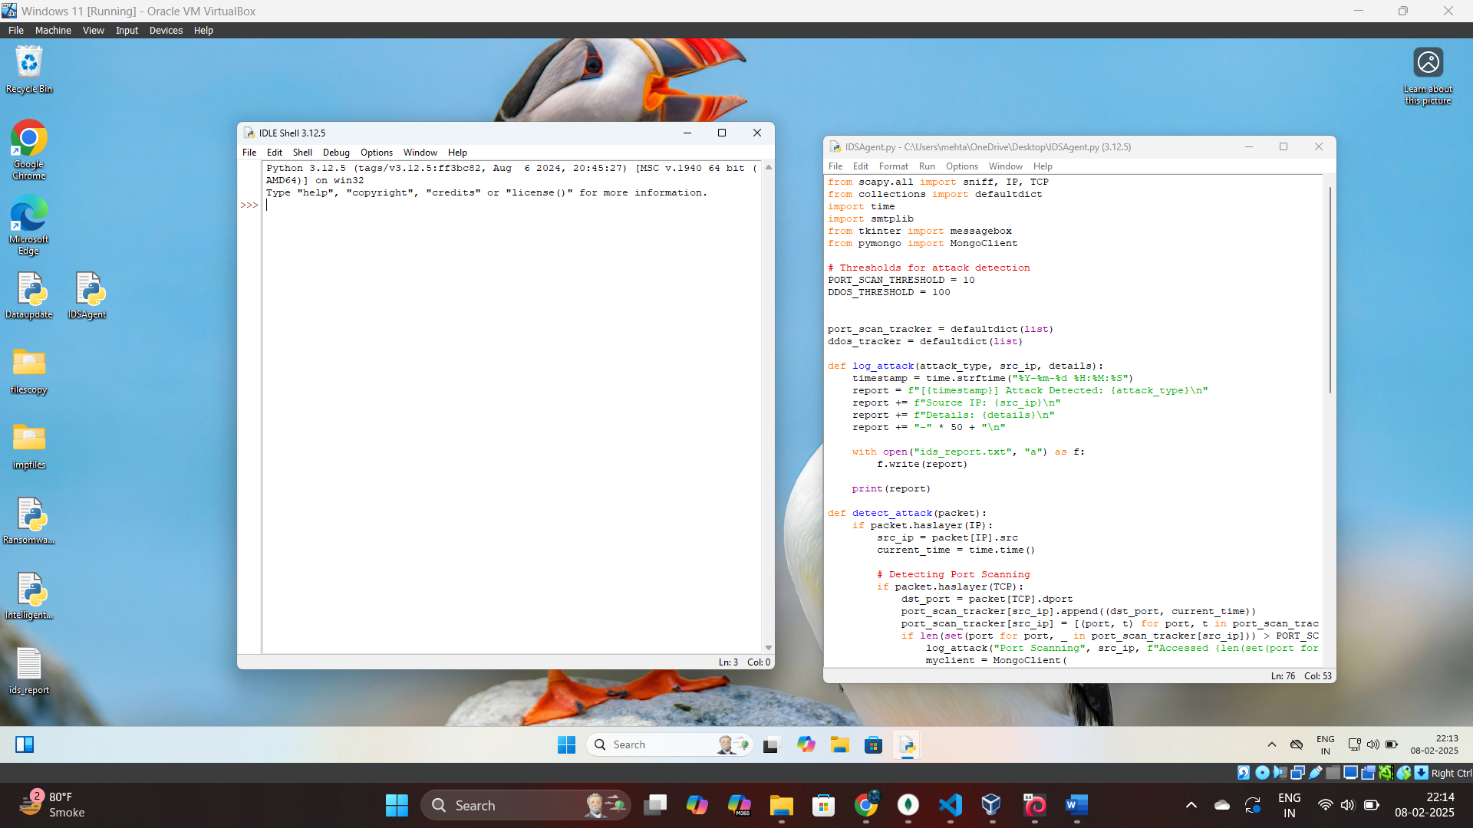

**It will start scanning and continuously scans the upcoming network traffic to detect potential threats:-**

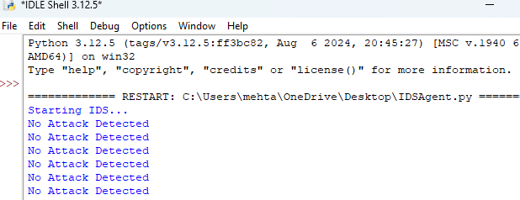

**Now we will launch the DOS Attack from kali Linux for attack simulation :-**

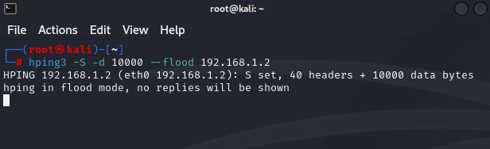

**As soon as the attack is launch the scripts detects it and send all the alerts and produces the report: -**

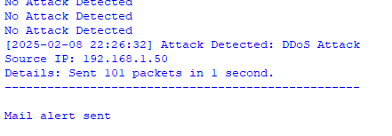

**The below alert is of victim machine:-**

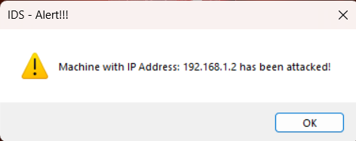

**The mail alert is also send automatically to the admin Email Address:-**

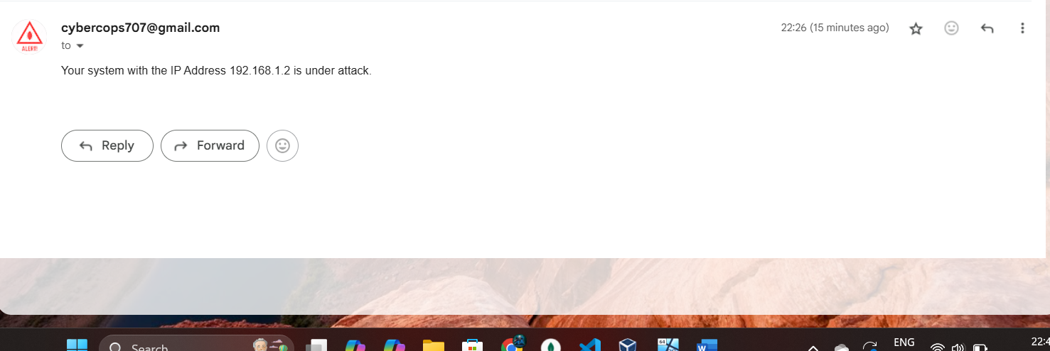

**The text file of report is also generated with the time of attack,type of attack,source IP of attacker,and extra details.**

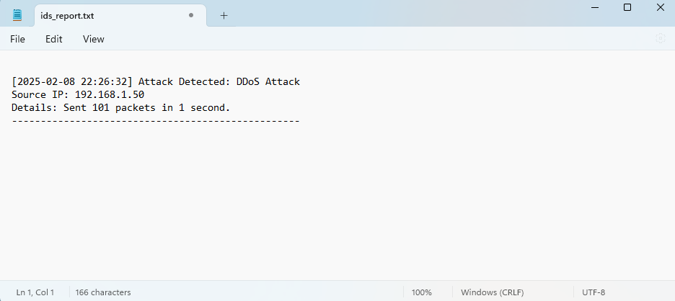

**The machine with IP 192.168.1.2 status is also changed to “attack”**

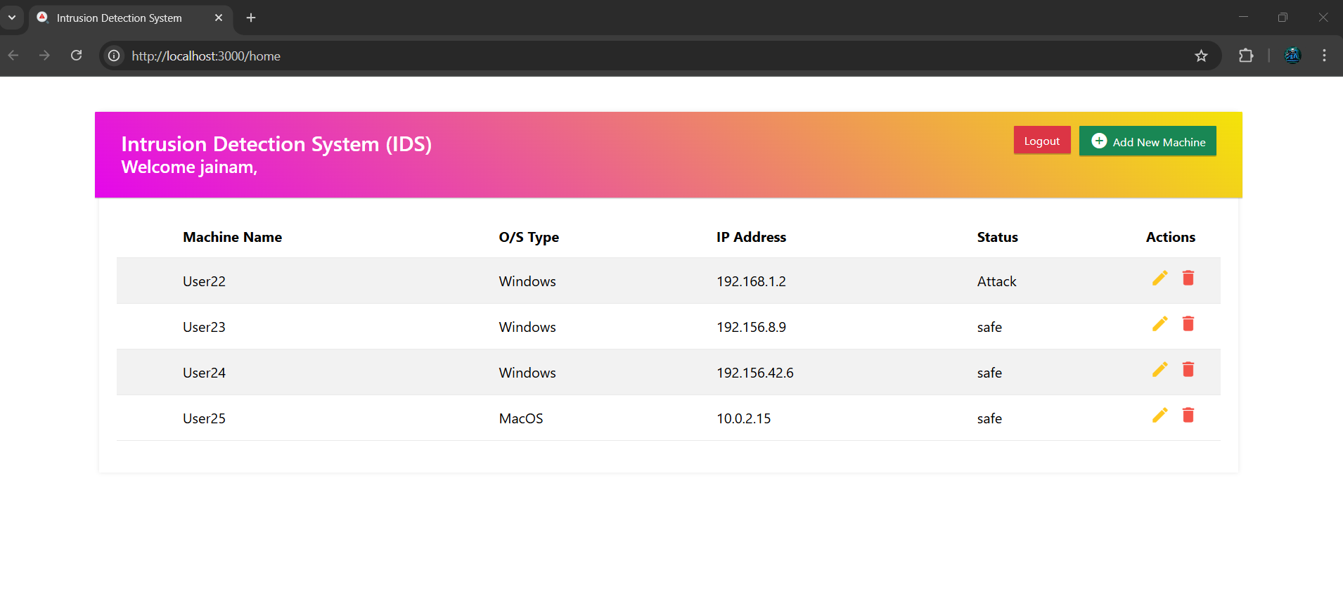

**It also gets changed in database:-**

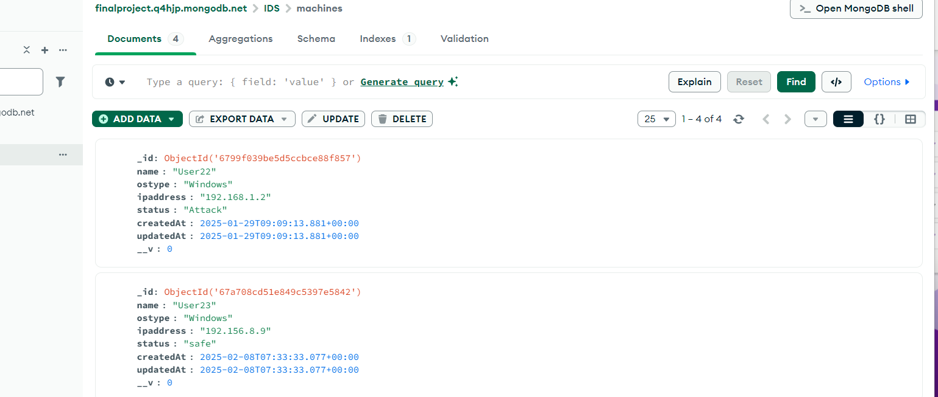

**The “IPScanner.py” script is used which scans to get alert on the admin machine where the UI is Situated:-**

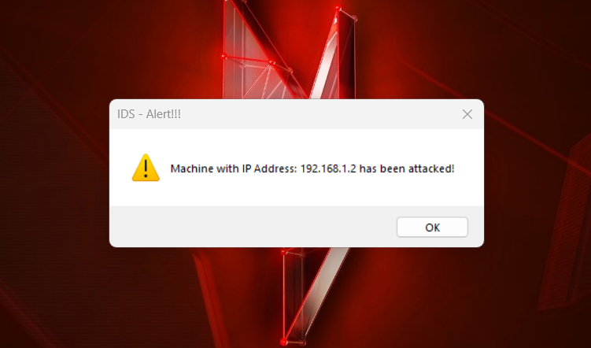

**So now you can take appropriate action on which machine has been attacked**